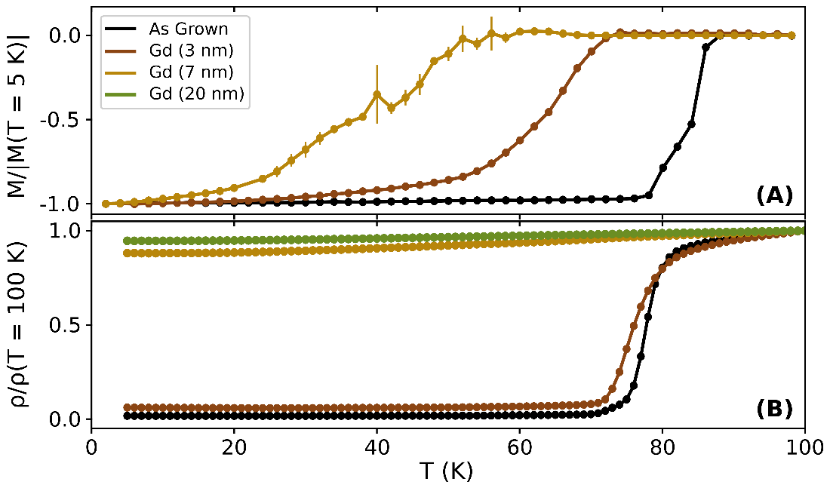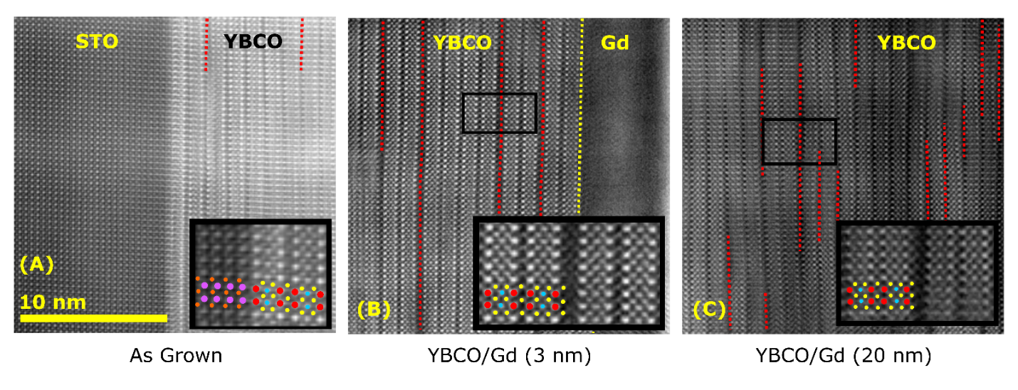

*(A) Superconducting transition measured by normalized magnetization (top) and resistivity (bottom). (B,C) Cross-sectional HAADF-STEM images of the Gd/YBCO interface for the Gd (3nm) sample (B) and the Gd (20nm) sample (C). The crystal structure is depicted with Cu, Ba, and Y atoms highlighted in yellow, red, and blue, respectively. Magnified views of the region highlighted by the black boxes are shown in the insets, illustrating vertically oriented CuO stacking faults in the middle.*